### Homework4.1

## type erasure:

Type erasure is **a process in which compiler replaces a generic parameter with actual class or bridge method**.

Unlimited type erasure:

**replaces a generic parameter with Object.**

Limited type erasure:

## <? extends E> replaces generic parameters with E

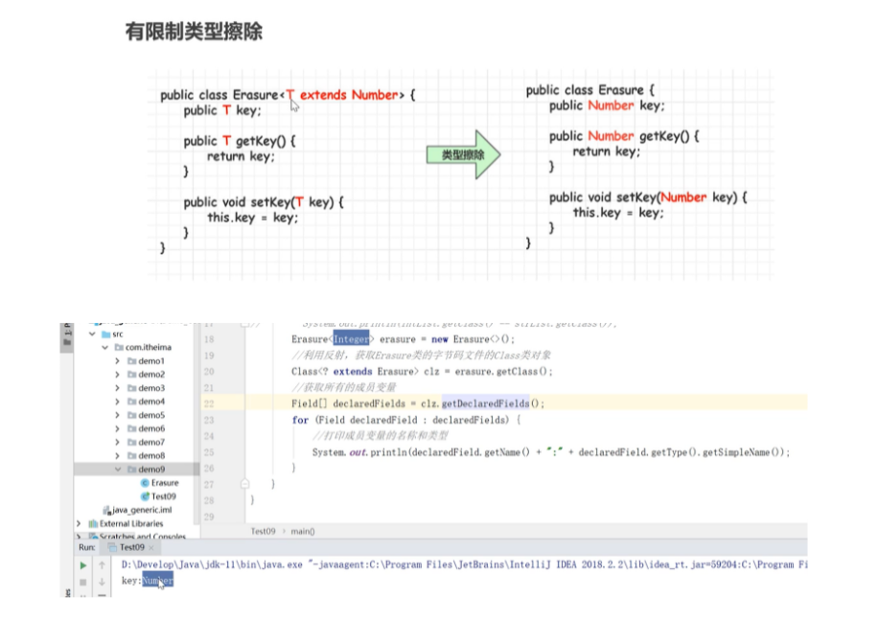

## <? super T> replaces generic parameters with Obj

Bridge Method:

These are **methods that create an intermediate layer between the source and the target functions**.

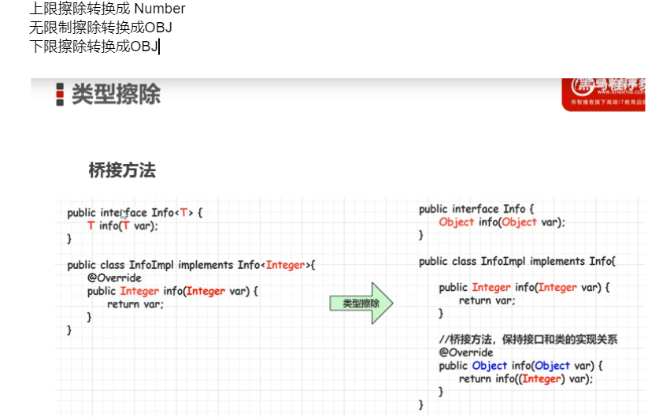

**Upper Bounds Wildcards:**

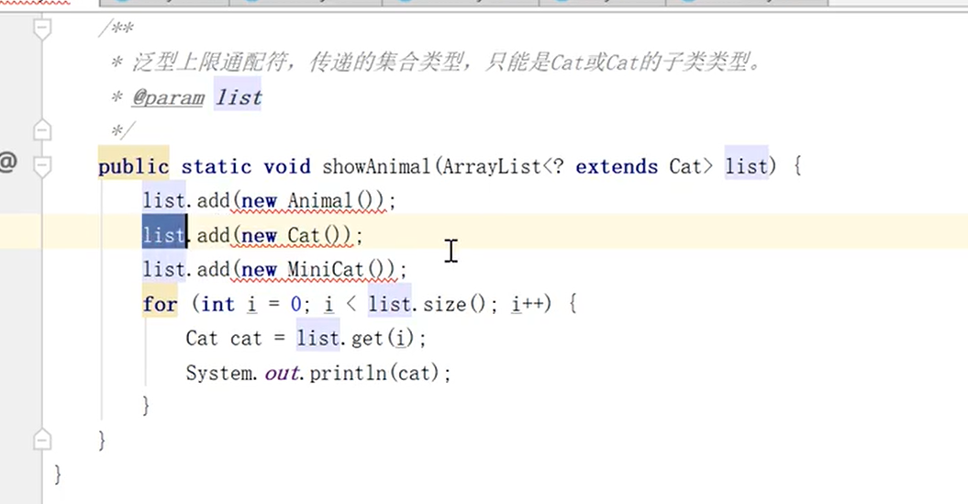

## <? extends E>

It requires the generic type is E or its subclass. We cannot add elements to the list.

ArrayList<? extends E> list.

Lower Bounds Wildcards:

## <? super T>

It requires the generic type is E or its parent-classes. We can only get elements from the list with an object.

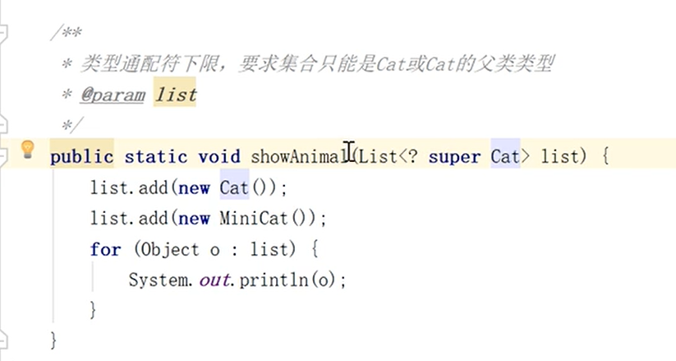

Homework 4.2

* explore other stream API, (10 API)
  + map, flatmap, distinct, limit…..

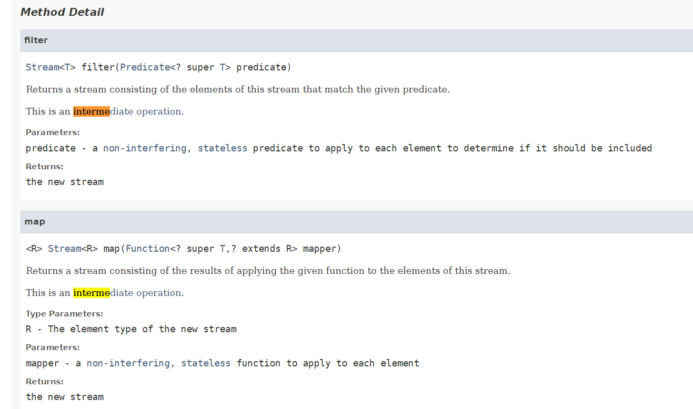

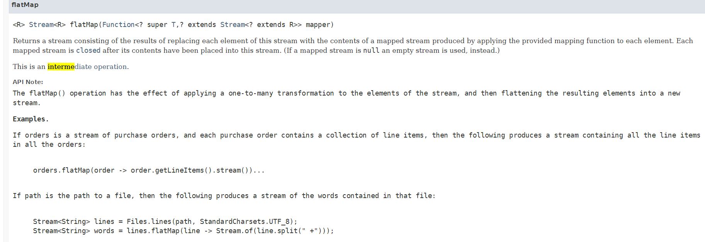

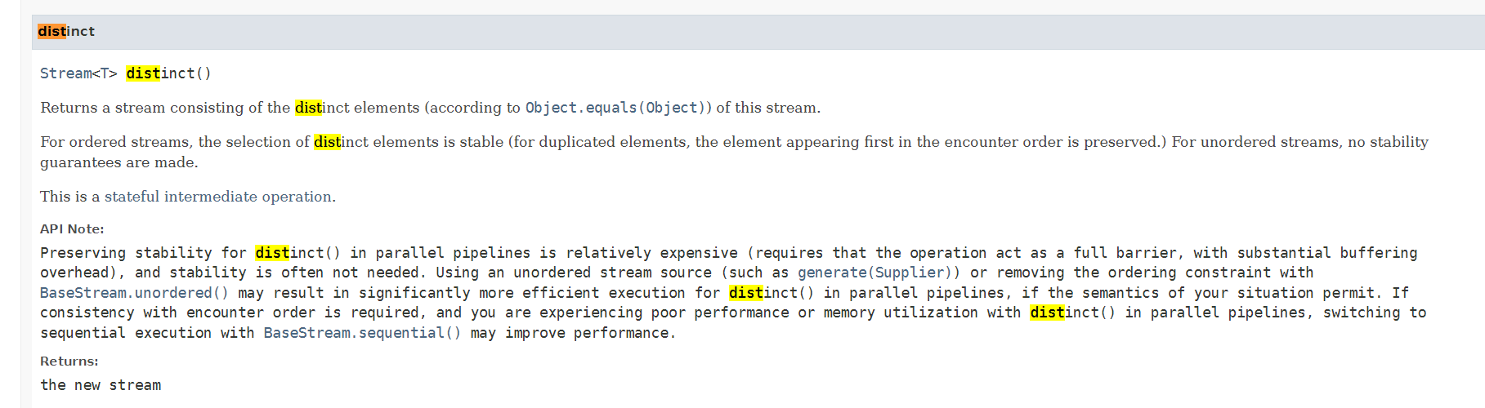

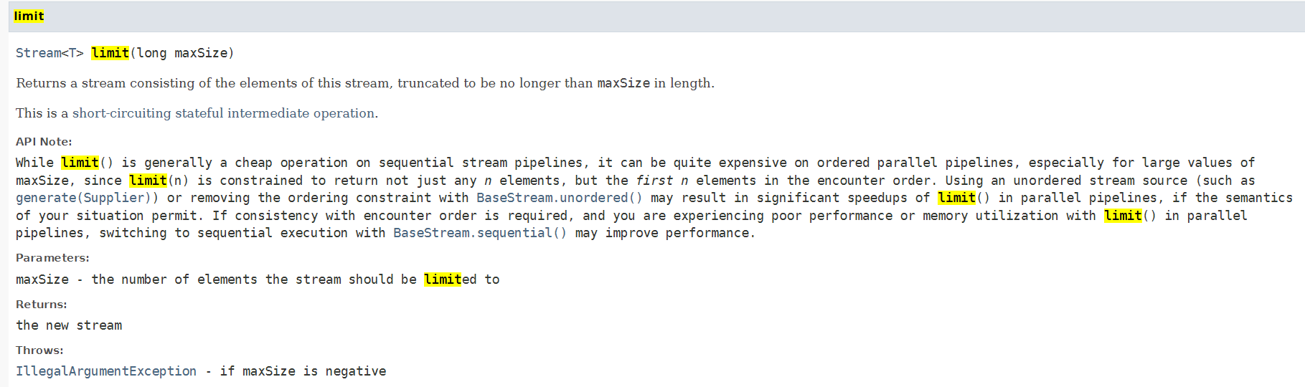

Sort a student using stream:

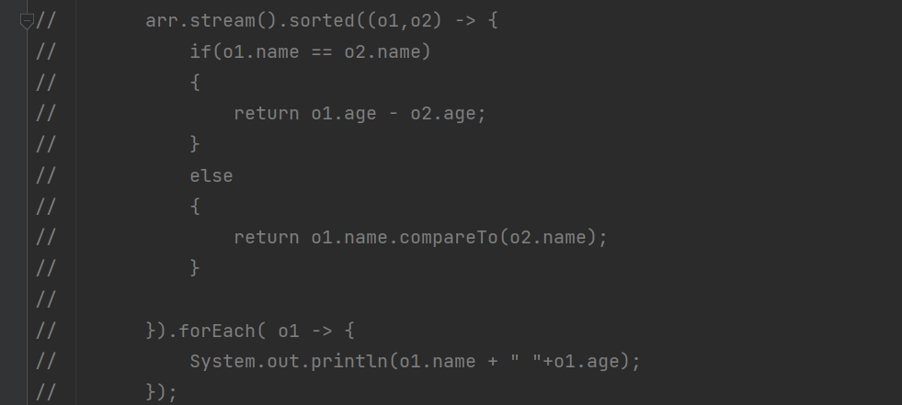

* Method reference

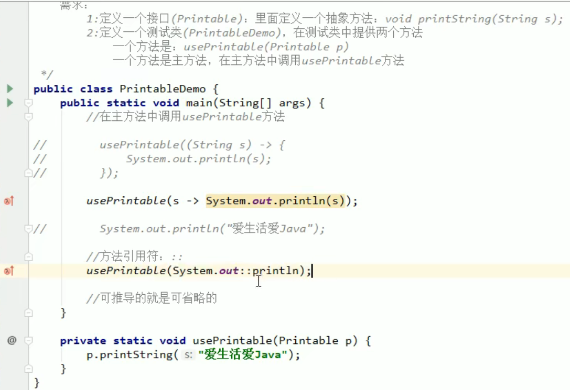

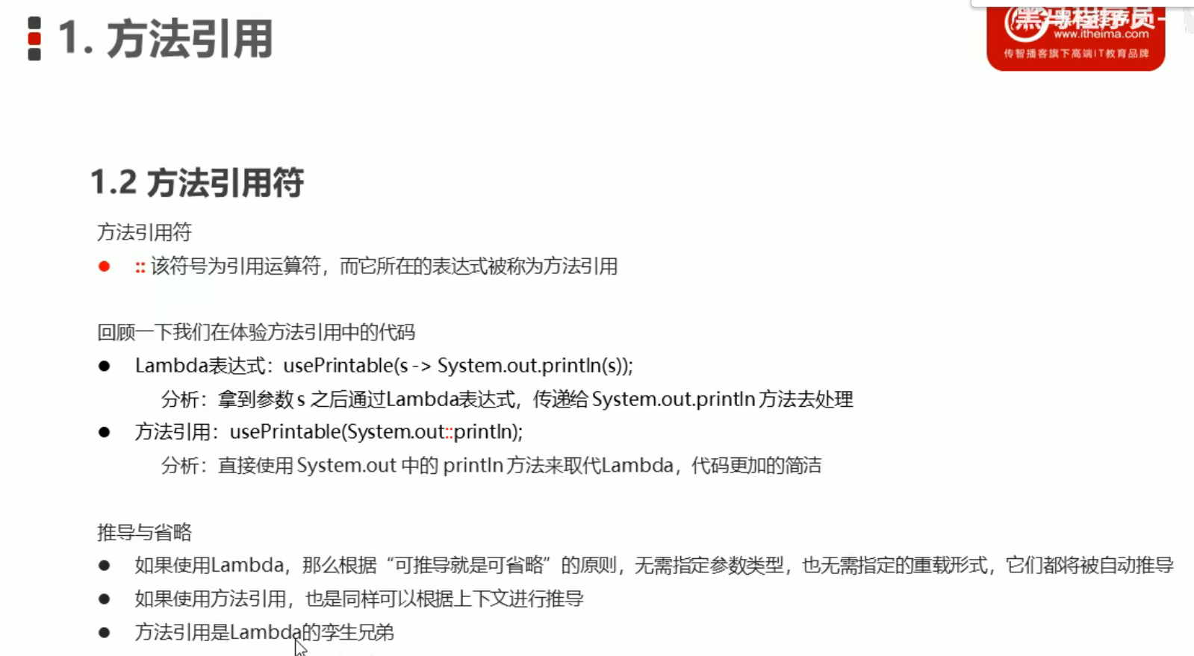

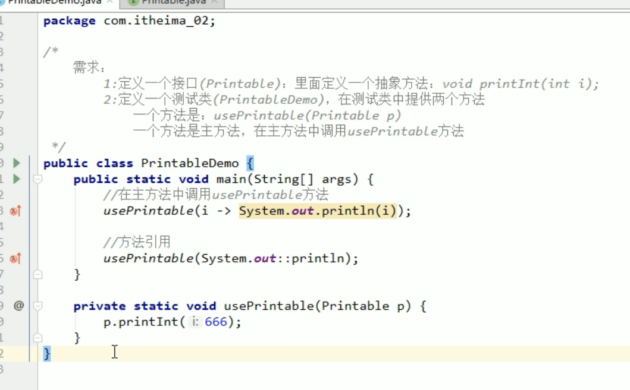

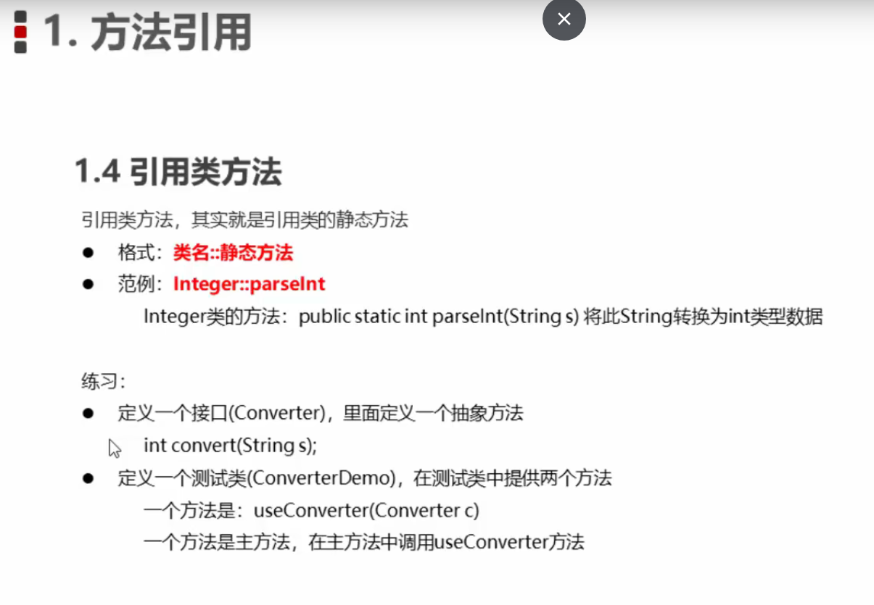

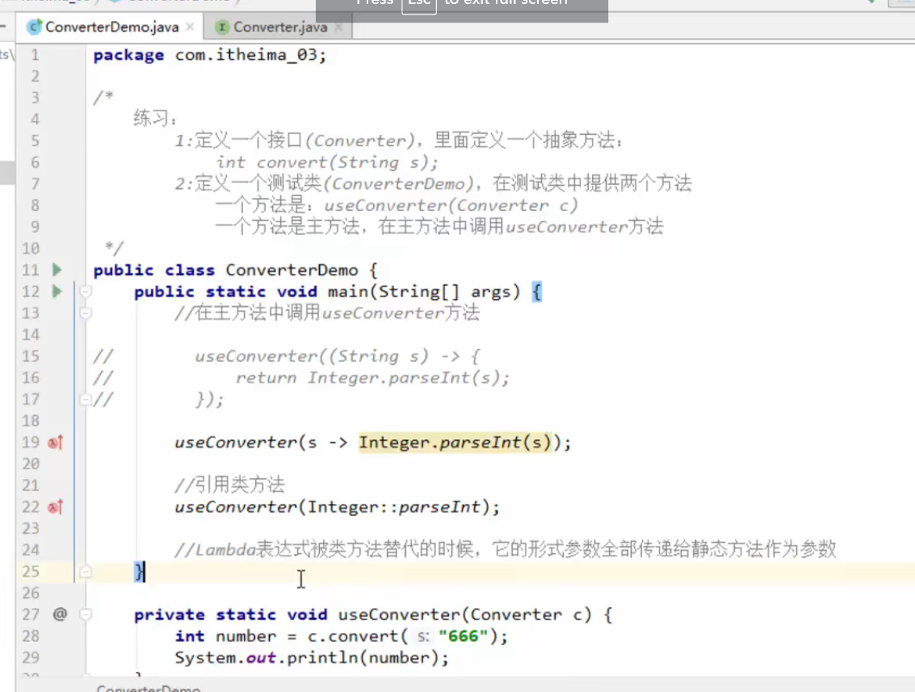

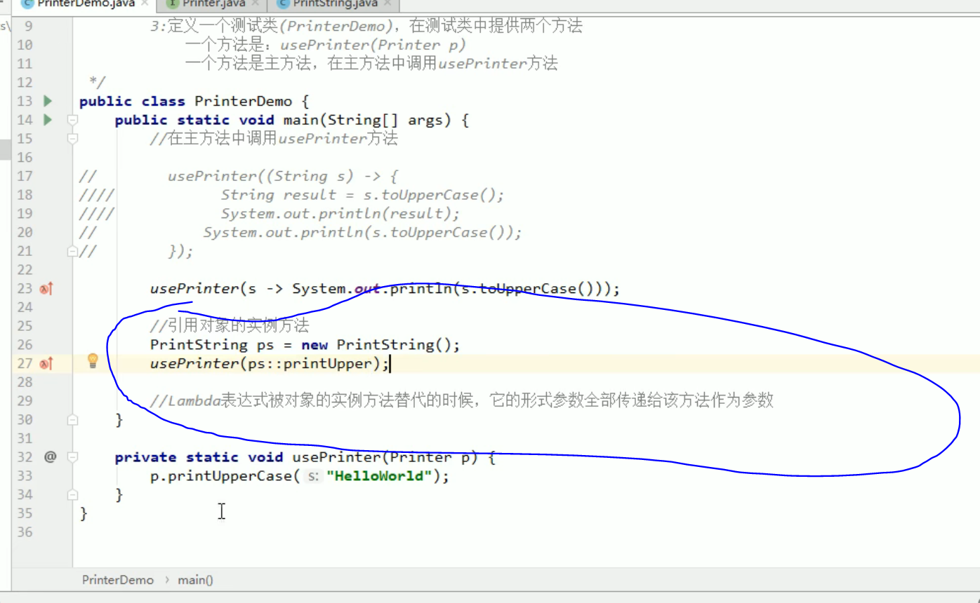

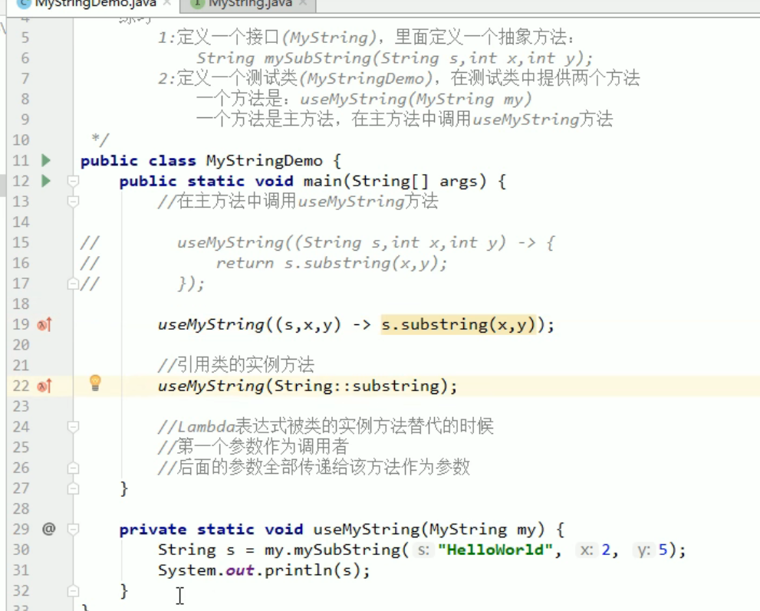

引用构造器：

